

TCS iON AIP 135 - A Neural Network Approach to Analyse Customer Metrics and Predict Buying Trends

Based
on
TCS-iON Internship Project
F. Y M. Sc-Statistics Data Science

by

- Abhinav M (31250837)

Under the Mentorship
of
Dr. Raeesa Bashir

Department of Mathematics and Statistics,
Faculty of Science and Technology,
Vishwakarma University, Pune
AY: 2025-26

SUMMARY
The TCS iON Industry Project titled “A Neural Network Approach to Analyse Customer Metrics and Predict Buying Trends” focuses on building an intelligent customer analytics system using a Multilayer Perceptron (MLP) Neural Network implemented through Apache Spark (PySpark). Leveraging a large retail transaction dataset of 100,000 customer records with rich demographic, behavioral, and transactional attributes, the project aimed to predict customer spending behavior by classifying customers into High, Medium, and Low Spenders. A Multilayer Perceptron Classifier was successfully designed and trained using PySpark MLlib, achieving a strong test accuracy of 85.94% and an F1 score of 85.99% after applying feature scaling with StandardScaler. Comprehensive Exploratory Data Analysis uncovered actionable insights into purchasing patterns, product preferences, regional performance, loyalty impact, and promotion effectiveness. A complete end-to-end pipeline was developed, including data preprocessing, feature engineering (StringIndexer, OneHotEncoder, VectorAssembler), model training, hyperparameter experimentation, evaluation, and deployment with model saving and inference. Multiple visualizations such as correlation heatmaps, spending distributions, product category analysis, and prediction probability breakdowns were generated. The business value of this project lies in enabling retail companies to identify high-value customers for targeted marketing, optimize inventory planning by product category and region, improve segmentation and loyalty program effectiveness, and reduce marketing budget wastage by focusing efforts on customers most likely to respond. Overall, the project demonstrates a practical application of neural networks in retail analytics, combining strong predictive capability with deep business intelligence to deliver both technical excellence and strategic value.

TABLE OF CONTENTS

Title Page No.
ABSTRACT i
Abstract
- Introduction 1
  - Project Background . . . . . . . . . . . . . . . . . . . . . . . . . . . . . . 1
  - Problem Statement . . . . . . . . . . . . . . . . . . . . . . . . . . . . . . 2
  - Project Objectives . . . . . . . . . . . . . . . . . . . . . . . . . . . . . . 2-3
  - Scope of the Project . . . . . . . . . . . . . . . . . . . . . . . . . . . . . 3
  - Significance of the Project . . . . . . . . . . . . . . . . . . . . . . . . . . 3
- Literature Review 4
  - Introduction to Literature Review . . . . . . . . . . . . . . . . . . . . . . 4
  - Customer Analytics in Retail . . . . . . . . . . . . . . . . . . . . . . . . 4
  - Machine Learning in Customer Behavior Prediction . . . . . . . . . . . . 4-5
  - Neural Networks and Deep Learning in Retail . . . . . . . . . . . . . . . 5
  - Role of Big Data Tools in Machine Learning . . . . . . . . . . . . . . . . 5-6
  - Research Gap . . . . . . . . . . . . . . . . . . . . . . . . . . . . . . . . . 6
  - Conclusion of Literature Review . . . . . . . . . . . . . . . . . . . . . . . 6
- Data Description & Methodology 7
  - Introduction . . . . . . . . . . . . . . . . . . . . . . . . . . . . . . . . . . 7
  - Dataset Description . . . . . . . . . . . . . . . . . . . . . . . . . . . . . . 7-8
    - Dataset Source and Overview . . . . . . . . . . . . . . . . . . . . 7-8
    - List of Attributes . . . . . . . . . . . . . . . . . . . . . . . . . . . 8
    - Target Variable Derivation . . . . . . . . . . . . . . . . . . . . . . 8
  - Research Methodology . . . . . . . . . . . . . . . . . . . . . . . . . . . . 8
    - Tools and Technologies Used . . . . . . . . . . . . . . . . . . . . . 8

    - Data Preprocessing Steps . . . . . . . . . . . . . . . . . . . . . . 8
    - Feature Engineering . . . . . . . . . . . . . . . . . . . . . . . . . 8-9
    - Model Building and Training . . . . . . . . . . . . . . . . . . . . 9
    - Model Evaluation Strategy . . . . . . . . . . . . . . . . . . . . . . 9
    - Model Deployment . . . . . . . . . . . . . . . . . . . . . . . . . . 9

Exploratory Data Analysis (EDA) 11
  - Introduction . . . . . . . . . . . . . . . . . . . . . . . . . . . . . . . . . . 11
  - Data Quality and Class Distribution . . . . . . . . . . . . . . . . . . . 11-12
  - Income and Gender vs Spending Behaviour . . . . . . . . . . . . . . . . . 12
  - Regional and Product Category Analysis . . . . . . . . . . . . . . . . . . 13
  - Scatter Plot Analysis . . . . . . . . . . . . . . . . . . . . . . . . . . . . . 13
  - Correlation Matrix . . . . . . . . . . . . . . . . . . . . . . . . . . . . . . 14
  - Customer Value Analysis . . . . . . . . . . . . . . . . . . . . . . . . . . .14-15
  - Promotions and Satisfaction . . . . . . . . . . . . . . . . . . . . . . . . . 15

Model Building and Implementation 16
  - Introduction 17
  - Feature Engineering 17-18
  - Hyperparameter Tuning and Model Experimentation 19
  - Final Model Performance 19-20
  - Project Summary — Key Findings 21
  - Model Deployment 21
  - Challenges and Resolutions 22
  - Inference Phase Visualisations 22

Conclusion & Future Scope 12
  - Conclusion 23
  - Business Recommendations 23
  - Future Scope 24
REFRENCES 25
APPENDIX 26

CHAPTER 1
INTRODUCTION
1.1 Project Background
The retail industry is undergoing a massive digital transformation. With the explosion of customer data from online and offline transactions, businesses now have access to unprecedented insights into consumer behavior. However, the real challenge lies in converting this raw data into actionable intelligence that can drive revenue growth, customer retention, and operational efficiency.
In the current competitive landscape, organizations are increasingly adopting Artificial Intelligence (AI) and Machine Learning (ML) technologies to understand customer preferences, forecast demand, and personalize marketing efforts. Neural Networks, particularly Multilayer Perceptron (MLP) models, have proven highly effective in identifying complex, non-linear relationships within large datasets.
This TCS iON Industry Project titled “A Neural Network Approach to Analyse Customer Metrics and Predict Buying Trends” is a practical implementation of these advanced techniques in the retail domain. The project focuses on building a robust predictive model that can classify customers into distinct spending segments, thereby enabling businesses to make smarter, data-driven decisions.
1.2 Problem Statement
Despite having access to vast amounts of customer data, many retail companies still rely on traditional, rule-based segmentation methods that are often inaccurate, time-consuming, and fail to capture the dynamic nature of consumer behavior. Key challenges include:
- Difficulty in accurately identifying High-Value customers (High Spenders) for targeted marketing.
- Inefficient allocation of marketing budgets due to poor customer segmentation.
- Lack of clear understanding of which customer attributes (demographics, loyalty status, purchase frequency, etc.) most strongly influence buying behavior.
- Limited ability to predict future purchase trends and market demand.
- Ineffective promotion strategies that fail to deliver expected ROI.
These limitations result in lost revenue opportunities, high customer churn, and suboptimal inventory management. There is a strong need for an intelligent, scalable, and accurate system that can automatically learn from historical data and predict customer spending behavior with high reliability.
1.3 Project Objectives
The primary objectives of this project are as follows:
- To design, develop, and implement a Multilayer Perceptron (MLP) Neural Network model using PySpark MLlib for multi-class classification of customer spending levels.
- To perform in-depth Exploratory Data Analysis (EDA) to uncover hidden patterns and relationships between customer metrics and purchasing behavior.
- To identify the most influential features contributing to prediction accuracy through feature engineering and model evaluation.
- To rigorously evaluate the model using standard classification metrics such as Accuracy, F1 Score, Weighted Precision, and Weighted Recall.
- To demonstrate model deployment by saving the trained model and performing real-time inference on new, unseen customer data.
- To derive meaningful business insights and provide strategic recommendations for retail organizations based on model outcomes.
1.4 Scope of the Project
- Dataset: Customer Purchases Behaviour Dataset (approx. 100,000 records) sourced from Kaggle.
- Target Variable: spending_level (High Spender, Medium Spender, Low Spender) derived using the 25th and 75th percentile method on purchase_amount.
- Features Used: Age, Gender, Income, Education, Region, Loyalty Status, Purchase Frequency, Product Category, Promotion Usage, and Satisfaction Score.
- Technology Stack: Python 3.9, Apache Spark (PySpark), Spark MLlib, Pandas, Matplotlib, Seaborn.
- Deliverables:
  - Complete Jupyter Notebooks (Model Development + Business EDA)
  - Trained and saved MLP model
  - High-quality visualizations and graphs
  - Final project report and execution video
1.5 Significance of the Project
This project holds significant value for both academic learning and industry application. It demonstrates:
- The practical power of Neural Networks in solving real-world retail problems.
- End-to-end implementation of a Machine Learning pipeline using Big Data technology (PySpark).
- The ability to combine predictive analytics with deep business intelligence through rich visualizations and insights.
- How data-driven customer segmentation can lead to improved marketing ROI, better inventory planning, enhanced customer experience, and increased profitability.
By successfully completing this project, we showcase how advanced analytics can transform raw customer data into a powerful strategic asset for modern retail businesses.
CHAPTER 2
LITERATURE REVIEW
2.1 Introduction to Literature Review
This chapter reviews existing research and industry practices related to customer analytics, machine learning applications in retail, and the use of Neural Networks for predicting customer buying behavior. The review helps establish the theoretical foundation of the project and identifies the research gap that this TCS iON project addresses.
2.2 Customer Analytics in Retail
Customer analytics has become a cornerstone of modern retail strategy. According to many studies, retailers who effectively use customer data for segmentation and personalization achieve significantly higher customer lifetime value and marketing ROI.
Traditional customer segmentation methods such as RFM (Recency, Frequency, Monetary) analysis have been widely used for decades. However, these methods are often limited as they rely on simple statistical rules and fail to capture complex, non-linear relationships present in high-dimensional customer data.
2.3 Machine Learning in Customer Behavior Prediction
In recent years, Machine Learning techniques have shown superior performance in customer behavior modeling. Algorithms such as Decision Trees, Random Forest, Gradient Boosting (XGBoost, LightGBM), and Logistic Regression have been extensively applied for churn prediction, customer lifetime value estimation, and purchase propensity modeling.
Several researchers have demonstrated that ensemble learning methods often outperform traditional statistical models in retail datasets. However, these models sometimes struggle with highly complex pattern recognition tasks involving large volumes of categorical and numerical features.
2.4 Neural Networks and Deep Learning in Retail
Neural Networks, especially Multilayer Perceptrons (MLP) and deep learning architectures, have gained significant traction in retail analytics due to their ability to automatically learn hierarchical feature representations.
Studies have shown that Neural Networks perform exceptionally well in:
- Customer segmentation
- Demand forecasting
- Next-best-offer recommendation
- Spending level prediction
For instance, research on e-commerce platforms has shown that MLP models can effectively capture interactions between demographic variables (age, income, region) and behavioral variables (purchase frequency, promotion response) to predict future customer value.
2.5 Role of Big Data Tools in Machine Learning
With the exponential growth in retail data volume, traditional ML libraries (such as scikit-learn) often face scalability limitations. Apache Spark with its MLlib library has emerged as a powerful solution for distributed machine learning on large datasets.
PySpark MLlib provides scalable implementations of classification, regression, clustering, and feature engineering algorithms. Several industry case studies have successfully used PySpark for building end-to-end customer analytics pipelines on datasets exceeding millions of records.
2.6 Research Gap
While considerable research exists on:
- Traditional ML models for customer analytics,
- Deep learning applications in e-commerce recommendation systems,
There is limited published work that combines:
- Multilayer Perceptron Neural Networks with PySpark for customer spending level classification on large retail datasets.
- A dual focus on both predictive modeling and detailed business intelligence through rich visualizations and insights.
Most existing studies focus either on model accuracy or business insights, but rarely deliver both in a single end-to-end PySpark-based solution suitable for real-world retail deployment.
2.7 Conclusion of Literature Review
The literature clearly indicates a strong shift towards advanced Machine Learning and Neural Network techniques in retail analytics. However, there remains significant scope for projects that integrate scalable Big Data tools (PySpark) with Neural Networks to deliver both high predictive performance and actionable business intelligence.
This project aims to bridge this gap by developing a robust MLP-based customer spending prediction system supported by comprehensive EDA and business insights.

CHAPTER 3
DATA DESCRIPTION & METHODOLOGY
3.1 Introduction
This chapter presents a comprehensive description of the dataset used in the project and outlines the complete methodology followed during the project lifecycle. A thorough understanding of the data characteristics and the systematic approach adopted is critical for evaluating the validity, reliability, and reproducibility of the results. The methodology is designed following industry best practices for scalable machine learning using Big Data technologies.
3.2 Dataset Description
3.2.1 Dataset Source and Overview
The dataset used in this project is the Customer Purchases Behaviour Dataset by Sanyam Goyal, publicly available on Kaggle. It consists of 100,000 records (rows) and 12 attributes (columns). This dataset simulates real-world retail transaction data, making it highly suitable for customer analytics and predictive modeling.
The data captures detailed information about customer demographics, behavioral patterns, and transactional history, which are essential for understanding buying trends and building accurate predictive models.
3.2.2 List of Attributes
The dataset contains the following features:
Sr. No. | Attribute Name | Description | Data Type | Category
1 | age | Age of the customer | Integer | Demographic
2 | gender | Gender of the customer (Male / Female) | String | Demographic
3 | income | Annual income of the customer (in ₹) | Integer | Demographic
4 | education | Highest level of education attained | String | Demographic
5 | region | Geographic region of residence (East, West, North, South) | String | Geographic
6 | loyalty_status | Loyalty program tier (Gold, Silver, Regular) | String | Behavioral
7 | purchase_frequency | Frequency of purchases (frequent, occasional, rare) | String | Behavioral
8 | purchase_amount | Total monetary value of the purchase | Integer | Transactional
9 | product_category | Category of the product purchased | String | Transactional
10 | promotion_usage | Whether a promotion/discount was availed (0 = No, 1 = Yes) | Integer | Behavioral
11 | satisfaction_score | Customer satisfaction rating on a scale of 1 to 10 | Integer | Behavioral
12 | spending_level | Target Variable – Derived spending category | String | Target
Table 1: List of Attributes
3.2.3 Target Variable Derivation
Since the original dataset did not contain a direct target variable for classification, the spending_level was engineered from the purchase_amount column using a percentile-based approach (Statistical Bucketing):
- High Spender: Customers with purchase_amount ≥ 75th percentile (₹13,214)
- Medium Spender: Customers with purchase_amount between 25th and 75th percentile
- Low Spender: Customers with purchase_amount ≤ 25th percentile (₹5,587)
Final Class Distribution:
- Medium Spender: 49,149 records (49.15%)
- High Spender: 25,817 records (25.82%)
- Low Spender: 25,034 records (25.03%)
This method ensures a balanced yet business-relevant target variable that reflects actual spending power.

3.3 Research Methodology
The project was executed following a structured CRISP-DM (Cross-Industry Standard Process for Data Mining) framework, adapted for Big Data environments.
3.3.1 Tools and Technologies Used
- Programming Language: Python 3.9
- Distributed Computing Framework: Apache Spark 3.5.1 with PySpark
- Machine Learning Library: Spark MLlib
- Data Manipulation & Visualization: Pandas, Matplotlib, Seaborn
- Development Environment: Jupyter Notebook on Local Anaconda Setup
- Model Persistence: Spark’s native model saving format
3.3.2 Data Preprocessing Steps
- Data Ingestion: Loaded the CSV file into a PySpark DataFrame.
- Data Cleaning: Dropped the irrelevant id column. Verified absence of missing values.
- Target Variable Creation: Derived spending_level using percentile thresholds.
- Exploratory Data Analysis (EDA): Performed univariate, bivariate, and multivariate analysis with rich visualizations and correlation studies.
- Data Transformation: Handled categorical variables through encoding techniques.
3.3.3 Feature Engineering
- Categorical Variables: Applied StringIndexer followed by OneHotEncoder on six categorical columns (gender, education, region, loyalty_status, purchase_frequency, product_category).
- Numerical Variables: Retained age, income, promotion_usage, and satisfaction_score.
- Feature Vector Creation: Used VectorAssembler to combine all features into a single dense vector column (features) containing 27 dimensions.
- Feature Scaling: Applied StandardScaler to normalize all features. This step proved critical for improving Neural Network performance.
3.3.4 Model Building and Training
- Algorithm Selected: Multilayer Perceptron Classifier (MLP) — a feed-forward Artificial Neural Network.
- Best Model Architecture: Input Layer (27) → Hidden Layer 1 (128) → Hidden Layer 2 (64) → Hidden Layer 3 (32) → Output Layer (3)
- Training Configuration:
  - Maximum Iterations: 200
  - Block Size: 256
  - Learning Rate (stepSize): 0.05
  - Random Seed: 42
- Data Split: 80% Training set, 20% Test set (stratified random split with seed 42)
3.3.5 Model Evaluation Strategy
The model was evaluated using multiple standard classification metrics suitable for multi-class problems:
- Accuracy
- F1 Score (primary evaluation metric)
- Weighted Precision
- Weighted Recall
- Confusion Matrix (for detailed error analysis)
3.3.6 Model Deployment
- The final trained model was saved using Spark’s native saving mechanism.
- Inference capability was demonstrated by creating new synthetic customer records and generating spending level predictions using the loaded model.

CHAPTER 4
EXPLORATORY DATA ANALYSIS (EDA)
4.1 Introduction
Exploratory Data Analysis (EDA) is a critical phase in any data science project. It helps in understanding the underlying structure of the data, detecting patterns, identifying outliers, and gaining valuable business insights before moving into model building.
In this project, extensive EDA was performed using PySpark for distributed computing and Pandas, Matplotlib & Seaborn for high-quality visualizations. This chapter presents the key findings from both statistical analysis and graphical representations.

4.1 Data Quality and Class Distribution
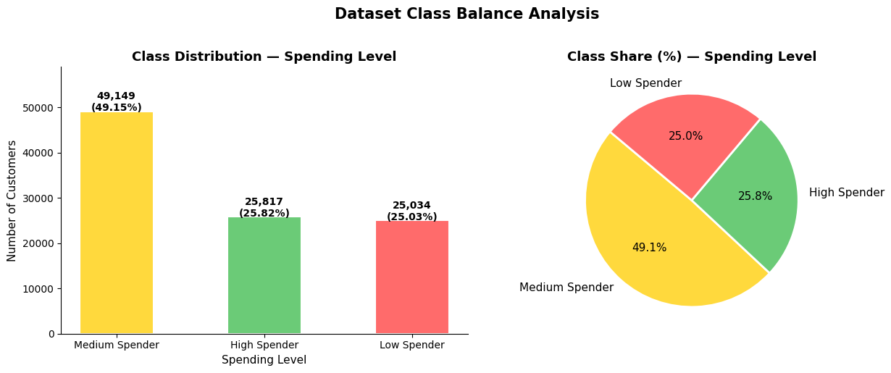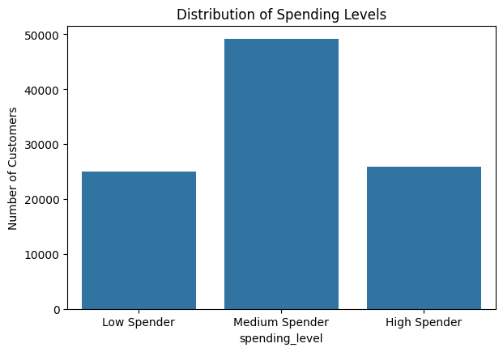Img 1 : Dataset Class Balance Analysis Img 2 : Distribution of Spending Levels

- The missing value audit confirmed zero null values across all eleven columns, meaning the full dataset was used for analysis and training without any imputation or row removal.
- The bar and pie chart together show that the class split is moderately balanced across the three tiers, with no extreme dominance by any single class — confirming that the dataset was suitable for MLP training without requiring oversampling or class weighting.

4.2 Income and Gender vs Spending Behaviour
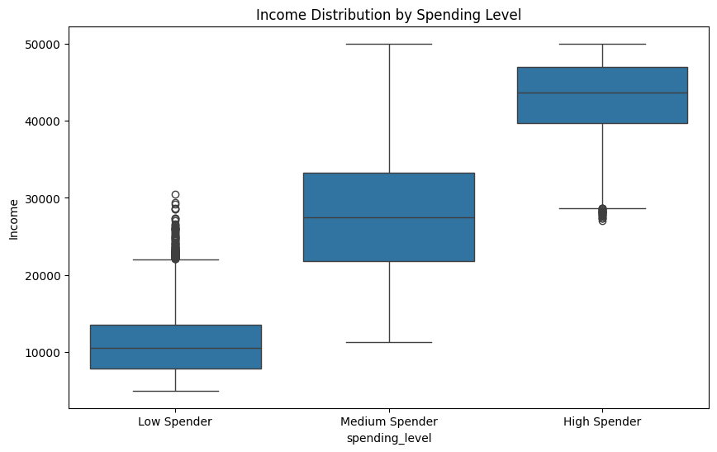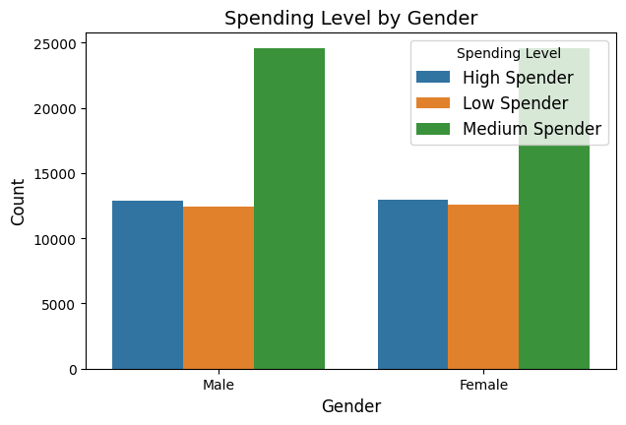 Img 3 : Income Distribution by Spending Level Img 4 : Spending Level by Gender

- The income box plot reveals that income distributions across all three spending tiers overlap significantly — High Spenders are not exclusively from high-income brackets, and Low Spenders are not confined to low-income groups.
- The gender count plot shows a near-symmetrical distribution of male and female customers across all three spending levels, indicating that gender does not act as a dominant discriminating feature for spending classification.

  - Regional and Product Category Analysis
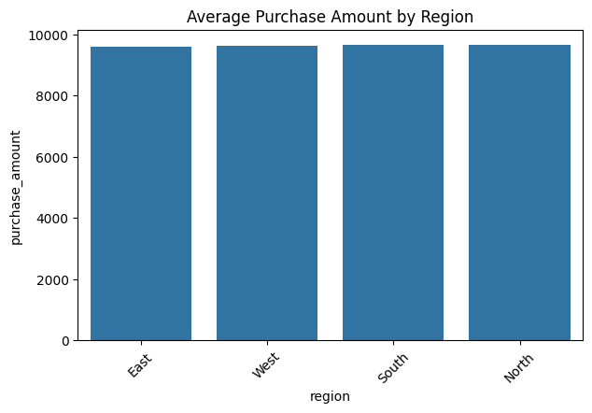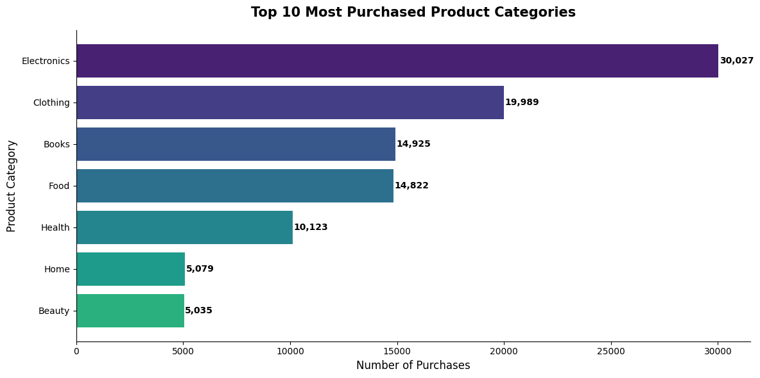
Img 5 : Average Purchase Amount by Region Img 6 : Top Product Categories Purchased

- The regional average purchase amount plot shows that average transaction values are broadly similar across all regions — East, West, South, and North — indicating that individual spending behaviour does not differ dramatically by geography.
- The top product categories chart reveals that Electronics dominates with approximately 30,027 purchases, nearly 50% more than Clothing in second place (19,989), followed by Books (14,925).
- The average revenue chart reveals a different ranking — Beauty (₹9,721), Food (₹9,670), and Electronics (₹9,648) lead in average transaction value, showing that high-volume categories are not always the highest-revenue ones per transaction.
- This dual analysis of volume and value is strategically important: Beauty and Food, despite lower purchase frequency, generate comparable revenue per sale to Electronics, identifying them as high-value but under-promoted categories.
- The grouped spending preference chart shows that all three spending tiers follow similar category preferences, with Electronics leading across all groups — however, High Spenders show a slightly stronger presence in Beauty and Electronics, while Low Spenders are more concentrated in Books and Clothing.
  - Scatter Plot Analysis — Feature Relationships
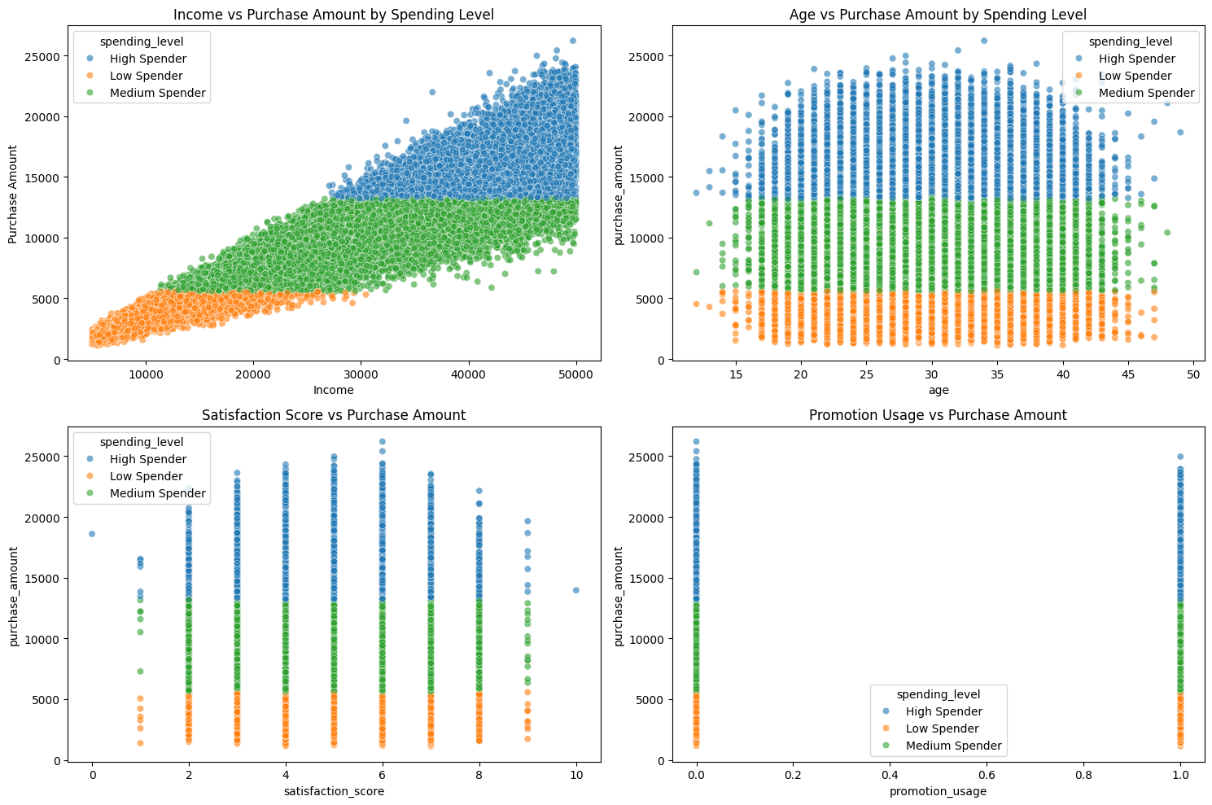
Img 7: Scatter Plot Analysis

- The Income vs Purchase Amount scatter shows data points from all spending tiers spread uniformly across the full income range, reconfirming that income is not a clean separator of spending classes.
- Collectively, all four scatter plots demonstrate that no single feature linearly separates the spending classes — reinforcing the necessity of a non-linear, multi-feature model like the MLP.
4.5 Correlation Matrix of Numerical Features
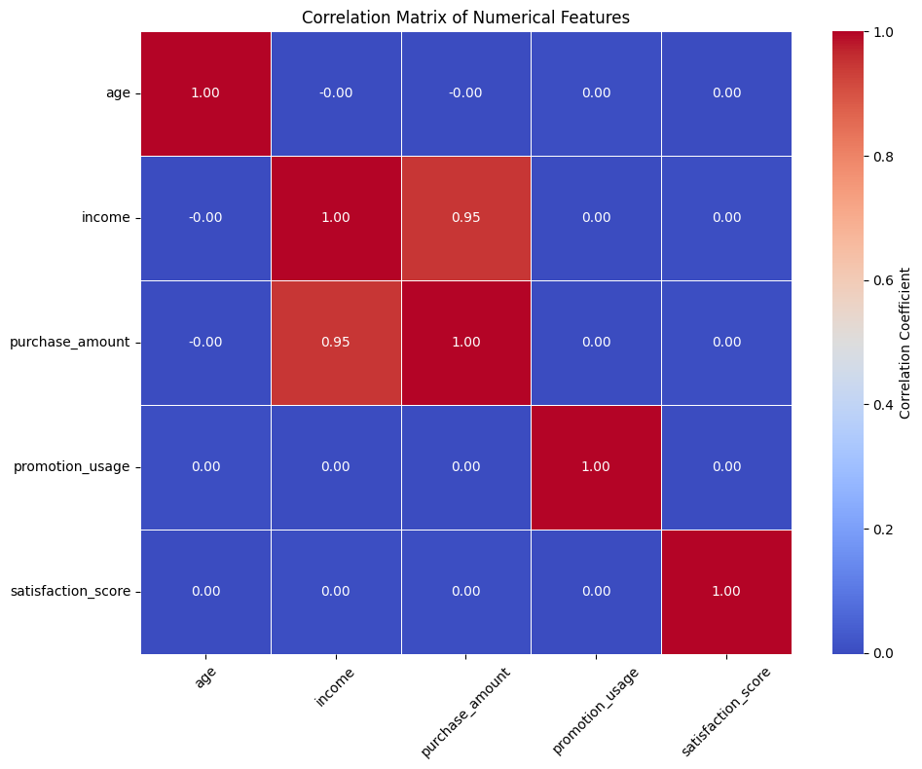
Img 8: Correlation Matrix of Numerical Features

- The correlation heatmap shows that all numerical features — age, income, promotion_usage, and satisfaction_score — have very low pairwise correlations with each other and with purchase_amount.
- The near-zero values across the matrix indicate low multi-collinearity in the feature set, meaning each numerical feature contributes relatively independent information to the model.
4.6 Customer Value — Loyalty, Income, and Segmentation
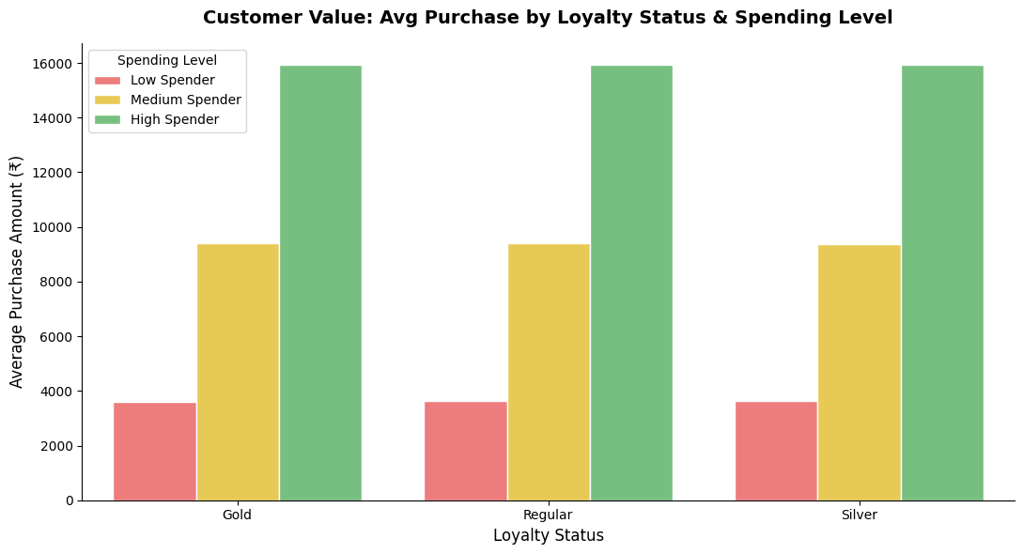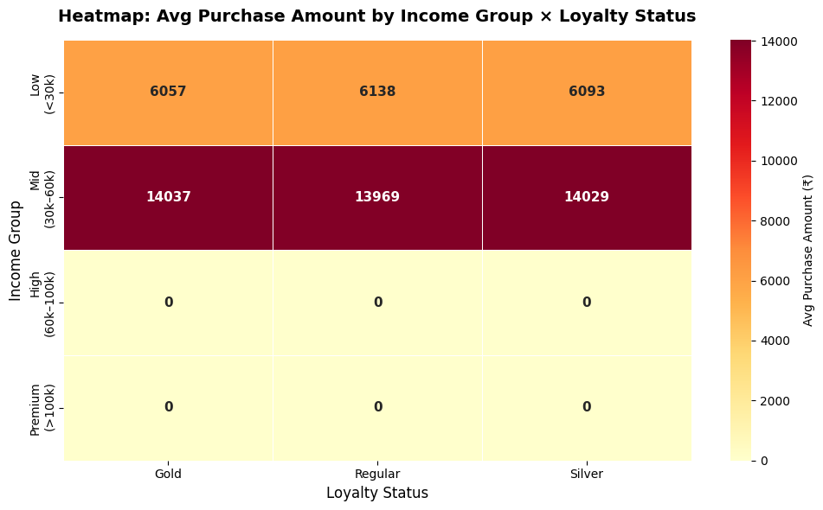
Img 9:Avg Purchase by Loyalty Status Img 10: Heatmap Income Group × Loyalty Status

- The loyalty status grouped bar chart reveals a counter-intuitive finding — Regular customers record the highest average spend (₹9,640), marginally ahead of Silver (₹9,629) and Gold (₹9,621) customers, with differences so small as to be practically negligible.
- The income group × loyalty status heatmap shows that across all combinations of income bracket and loyalty tier, the average purchase amounts remain broadly uniform with minimal variation.
4.7 Promotions, Regional Revenue, and Customer Satisfaction
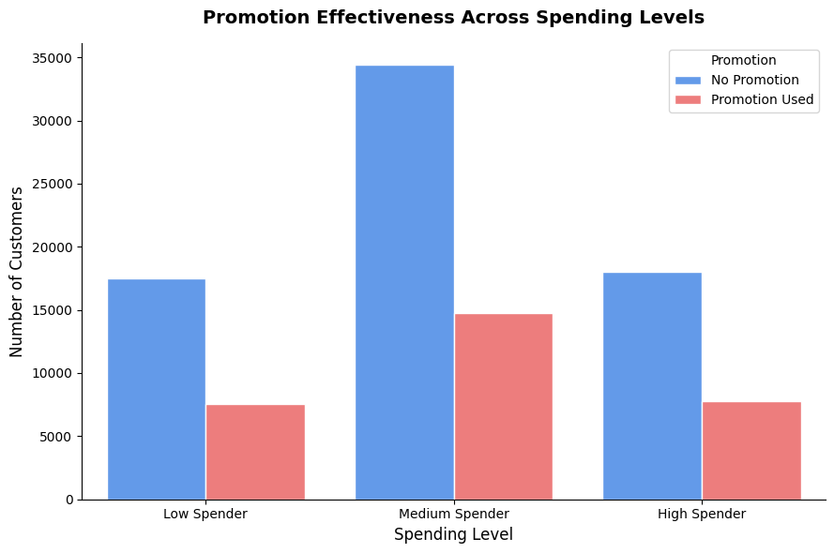
Img 11: Promotion Effectiveness Across Spending LevelsI
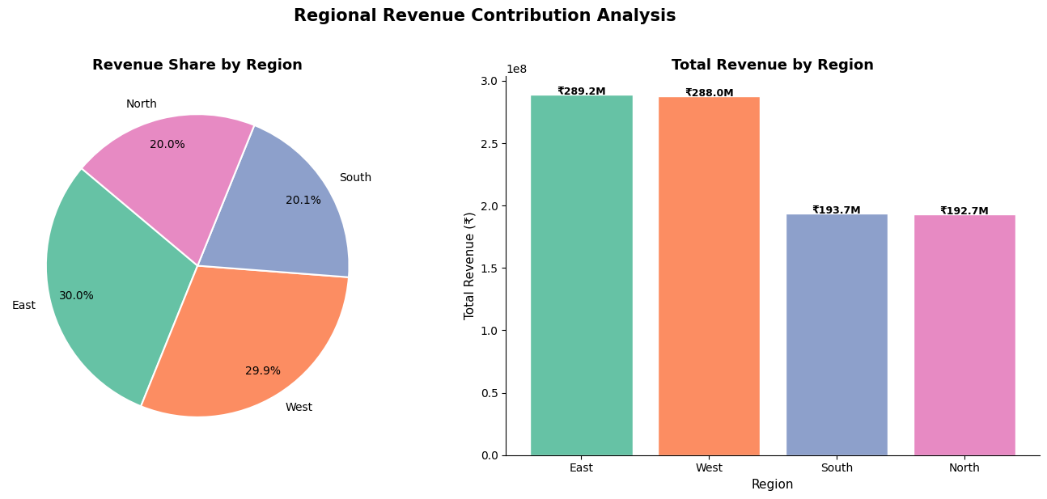
Img 12: Regional Revenue Contribution Analysis
- The promotion effectiveness chart shows that the ratio of promotion-using to non-promotion-using customers is nearly equal across all three spending tiers, with minimal difference in average spending between the two groups.
- The satisfaction score box plot shows that purchase amount distributions remain consistent across all satisfaction levels, indicating no strong relationship between satisfaction and spending behaviour.

CHAPTER 5
MODEL BUILDING AND IMPLEMENTATION

5.1 Introduction
This chapter presents the complete process of designing, developing, and implementing the Multilayer Perceptron (MLP) Neural Network model, which forms the core of this project. The objective of this phase is to transform the processed dataset into a predictive model capable of accurately classifying customers into different spending categories.
The implementation process involves several critical stages, including feature engineering, model architecture design, hyperparameter tuning, model training, and performance evaluation. Multiple iterations of experimentation were carried out to identify the most optimal configuration of the neural network. Each iteration provided insights into the behaviour of the model and helped refine its performance.
The final model was selected based on its ability to generalize well on unseen data while maintaining high accuracy and balanced evaluation metrics. Additionally, the trained model was deployed and tested on new input data to validate its real-world applicability.

5.2 Feature Engineering
Feature engineering played a crucial role in preparing the dataset for effective neural network training. Since neural networks are sensitive to input representation, careful preprocessing was required to ensure that all features were in a suitable numerical format.
Categorical variables such as gender, education, region, loyalty_status, and product_category were transformed into numerical representations using a combination of StringIndexer and OneHotEncoder. This process converted each categorical variable into a sparse binary vector, ensuring that no ordinal relationship was incorrectly introduced between categories.
Numerical features including age, income, promotion_usage, and satisfaction_score were retained in their original form, as they already represented meaningful quantitative information. These features provide important signals related to customer demographics and behavioural patterns.
All processed features were then combined into a single feature vector using the VectorAssembler. The final feature vector consisted of 27 dimensions, representing both encoded categorical variables and numerical inputs.
To improve model performance and ensure faster convergence, feature scaling was applied using StandardScaler. This step normalized all feature values to a common scale, preventing features with larger magnitudes from dominating the learning process. The inclusion of scaling proved to be a critical factor in achieving high model accuracy.

5.3 Hyperparameter Tuning and Model Experimentation
The development of the neural network involved multiple rounds of experimentation to determine the optimal architecture and parameter settings. Initially, baseline models were trained without feature scaling and with simpler architectures. These models exhibited limited predictive capability, with accuracy levels around 50%, indicating underfitting.
Subsequent experiments involved increasing the complexity of the network by adding more hidden layers and neurons. However, without proper feature scaling, these changes did not yield significant improvements in performance.
The final breakthrough was achieved by incorporating feature scaling using StandardScaler. This allowed the neural network to learn effectively and converge towards an optimal solution.
Experiment Summary:
- Experiment 1: Architecture [27, 64, 32, 3], without scaling → Accuracy ~50.46%, poor performance
- Experiment 2: Architecture [27, 128, 64, 32, 3], without scaling → Accuracy ~50.46%, no improvement
- Experiment 3 (Final): Architecture [27, 128, 64, 32, 3], with scaling → Accuracy 85.94%, significant improvement
The final model configuration included three hidden layers with 128, 64, and 32 neurons respectively. This deep architecture enabled the model to capture complex non-linear relationships between input features and the target variable.
Key hyperparameters of the final model were:
- Hidden Layers: [128, 64, 32]
- Maximum Iterations: 200
- Learning Rate: 0.05
- Block Size: 256
The dramatic improvement in performance after scaling highlights the importance of proper data preprocessing in neural network models.

5.4 Final Model Performance
The final Multilayer Perceptron model was evaluated on the test dataset, which consisted of unseen data not used during training. The model demonstrated strong predictive performance across all evaluation metrics.
- Test Accuracy: 85.94%
- F1 Score: 85.99%
- Weighted Precision: 86.02%
- Weighted Recall: 85.94%
The high accuracy indicates that the model is able to correctly classify a large proportion of customers into their respective spending categories. The F1 score, which balances precision and recall, further confirms the robustness of the model.
The consistency between precision and recall values suggests that the model does not favour any particular class and performs well across all spending categories. This is particularly important in multiclass classification problems, where balanced performance is essential.
Overall, the model demonstrates strong generalization capability and is suitable for real-world deployment.

5.5 Project Summary — Key Findings
The final model achieved an accuracy of approximately 85.94% and an F1 score of 85.99%, indicating high reliability in predicting customer spending behaviour.
The neural network architecture used in this project consisted of an input layer with 27 features, followed by three hidden layers with 128, 64, and 32 neurons, and an output layer representing the three spending categories.
Analysis of model behaviour revealed that high spenders are generally associated with higher income levels, stronger loyalty status, and more frequent purchase activity. Additionally, certain product categories such as Electronics and Home were observed to be more prominent among high spending customers.
It was also observed that promotion usage does not significantly differentiate between spending levels, indicating that promotional strategies alone may not be sufficient to influence customer spending behaviour.
From a business perspective, the model provides actionable insights that can be used for targeted marketing. High-value customers can be identified and prioritized for premium services, personalized offers, and loyalty programs, thereby improving overall revenue generation and customer retention.

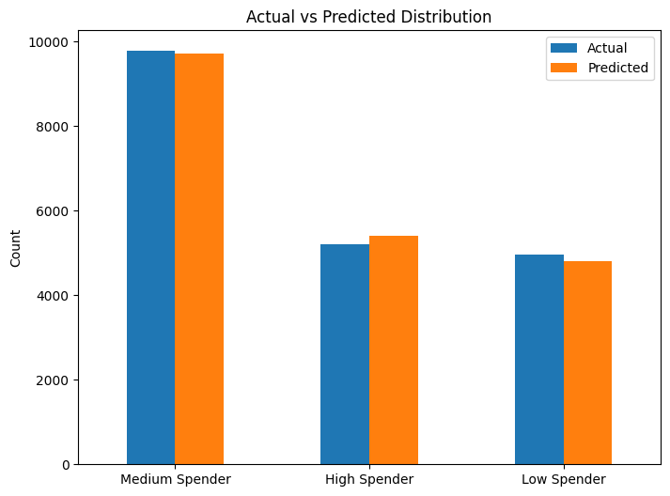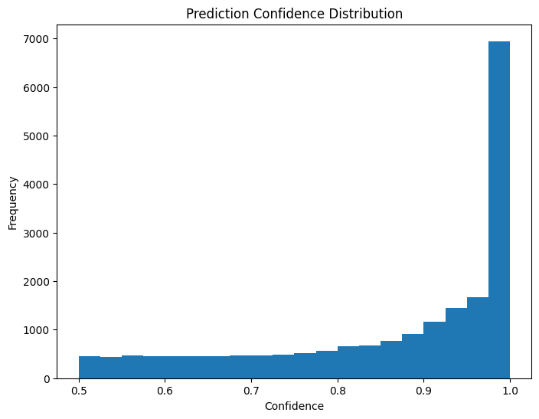
Img 16: Actual VS Predicted Img 17: Prediction Confidence Distribution

- Model Predictions on Infernce Data:

Age | Gender | Income | Region | Predicted Spending Level | Confidence (%)
35 | Male | 82,000 | North | High Spender | 99.98
28 | Female | 35,000 | South | Medium Spender | 63.04
50 | Male | 150,000 | West | High Spender | 99.98
22 | Female | 25,000 | East | Medium Spender | 99.57
45 | Male | 95,000 | North | High Spender | 99.98

Table 2 : Predictions on Infernce Data

- Confidence Breakdown Per Class
Predicted Spending Level | Confidence (%) | Low Prob (%) | Medium Prob (%) | High Prob (%)
High Spender | 99.98 | 0.00 | 0.02 | 99.98
Medium Spender | 63.04 | 0.00 | 63.04 | 36.96
High Spender | 99.98 | 0.00 | 0.02 | 99.98
Medium Spender | 99.57 | 0.42 | 99.57 | 0.01
Table 3: Confidence Breakdown Per Class
Inference Summary:
Predicted_Spending_Level
High Spender 3
Medium Spender 2

5.6 Model Deployment
The trained Multilayer Perceptron model was successfully saved and stored for future use. The model was exported to the specified directory, enabling it to be reloaded without retraining.
Path of saved model:
C:\Users\Aathira baskaran\Tcs_ion\mlp_model
To demonstrate deployment capability, the saved model was loaded and used to perform predictions on new, unseen customer data. This step simulates real-world usage, where incoming customer data can be processed and classified in real time.
The model outputs both the predicted spending category and the associated probability distribution across all classes. This allows businesses to not only classify customers but also understand the confidence of each prediction.

5.7 Challenges and Resolutions
During the development of the project, several challenges were encountered and addressed effectively.
One of the major challenges was the initially low model accuracy of approximately 50%. This issue was resolved by applying feature scaling, which significantly improved model convergence and performance.
Another challenge involved selecting the optimal neural network architecture. This was addressed through systematic experimentation with different layer configurations and hyperparameters until the best-performing model was identified.
Additionally, issues related to saving the model in a Windows environment were encountered due to Hadoop configuration requirements. These were resolved by properly setting up environment variables and ensuring compatibility with the PySpark framework.
Through these problem-solving steps, a stable and high-performing model was successfully developed and deployed.

5.6 Inference Phase Visualisations
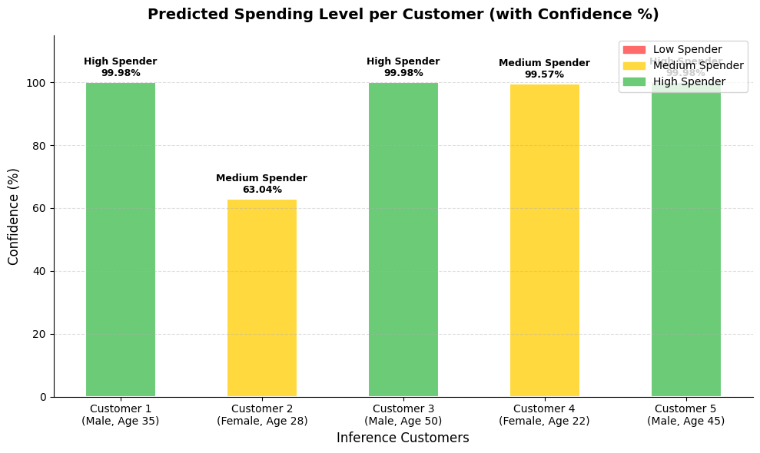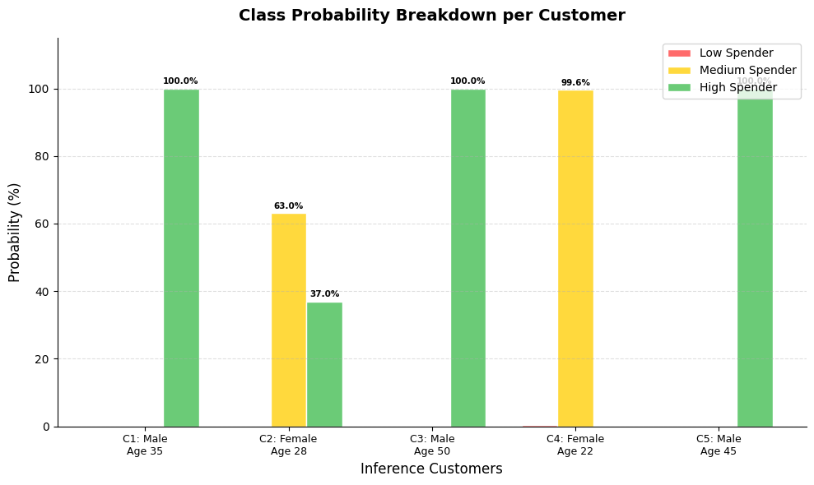
Img 13: Predicted Spending Level per Customer 14: Class Probability Breakdown per Customer

- The predicted spending level chart demonstrates that the trained MLP model can assign a spending category along with a confidence score for each new customer.
- The class probability breakdown shows the distribution of prediction probabilities across all three classes, providing deeper insight into model confidence and uncertainty.

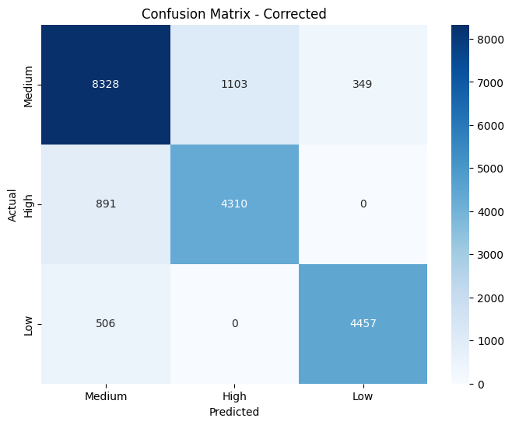
Img 15:Final Model Confusion Matri

CHAPTER 5
CONCLUSION & FUTURE SCOPE
6.1 Conclusion
This project successfully applied a Multilayer Perceptron (MLP) Neural Network to analyze customer data and predict buying trends by classifying customers into Low, Medium, and High spending categories.The exploratory analysis showed that no single feature independently determines spending behaviour; instead, it is influenced by multiple interacting factors. This justified the use of a neural network model capable of capturing non-linear relationships.
Through effective feature engineering, encoding, and feature scaling, the dataset was prepared for model training. After multiple rounds of experimentation, the final model achieved an accuracy of approximately 85.94% along with strong precision, recall, and F1 scores, indicating reliable performance.The model was also deployed and tested on new data, demonstrating its practical usability. From a business perspective, it enables better customer segmentation, targeted marketing, and data-driven decision-making.

6.2 Business Recommendations Based on Model Findings¶
Finding | Recommendation
Gold loyalty + High income = highest spenders | Target this segment with premium campaigns first
Electronics & Home are top High Spender categories | Prioritise stock and promotions in these categories
Promotions don't strongly separate spending levels | Redesign promotion strategy — blanket discounts are inefficient
North & West regions lead in revenue | Allocate higher marketing budget to these regions
Satisfaction score weakly correlated with spend | Focus on product quality over service alone
~25% customers are High Spenders | A small loyal segment drives disproportionate revenue
Table 4: Business Recommendations Based on Model Findings
.
6.3 Future Scope
The model can be further improved by incorporating additional features such as time-based purchasing patterns and customer interaction data to better capture evolving behaviour.
Advanced models such as Recurrent Neural Networks (RNNs) or Long Short-Term Memory (LSTM) networks can be explored for handling sequential data and improving prediction accuracy.The system can also be extended for real-time deployment, allowing businesses to make instant predictions and marketing decisions.
Further optimization can be achieved through automated hyperparameter tuning, cross-validation, and integration with business systems such as CRM platforms for personalized customer engagement.

REFERENCES

- Goodfellow, Y. Bengio, and A. Courville, Deep Learning. Cambridge, MA: MIT Press, 2016.
- C. M. Bishop, Pattern Recognition and Machine Learning. New York, NY: Springer, 2006.
- T. Hastie, R. Tibshirani, and J. Friedman, The Elements of Statistical Learning. New York, NY: Springer, 2009.
- S. Haykin, Neural Networks and Learning Machines, 3rd ed. Upper Saddle River, NJ: Pearson, 2009.
- F. Chollet, Deep Learning with Python. Shelter Island, NY: Manning Publications, 2017.
  - Géron, Hands-On Machine Learning with Scikit-Learn, Keras, and TensorFlow, 2nd ed. Sebastopol, CA: O’Reilly Media, 2019.
- J. Han, M. Kamber, and J. Pei, Data Mining: Concepts and Techniques, 3rd ed. Waltham, MA: Morgan Kaufmann, 2011.
- D. T. Larose and C. D. Larose, Discovering Knowledge in Data: An Introduction to Data Mining. Hoboken, NJ: Wiley, 2014.
- Apache Software Foundation, “Apache Spark MLlib Documentation,” [Online]. Available: https://spark.apache.org/docs/latest/ml-guide.html
- Kaggle, “Customer Behavior and Retail Dataset,” [Online]. Available: https://www.kaggle.com/

APPENDIX:
- Github Repo (Containing all files): Github-Repo
- EDA_Code: Advanced_EDA.ipynb
- Model_Devolpment_Code: TCS_iON_Neural_Network_Project.ipynb
- Dataset_kaggle_Link:customer-purchases-behaviour-dataset

